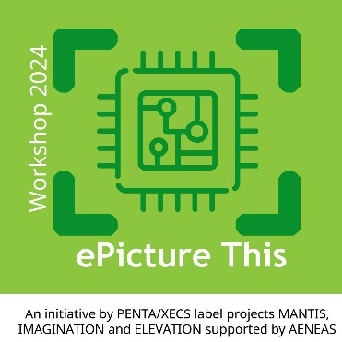
ABSTRACT PRESENTATION
Title:
Presenter name:
Company name / Institute:
Project name:
Funding group: Penta / Xecs / Euripides / ECSEL / KDT
Abstract can be published on website: ☐ YES ☐ NO

Provide abstract of 500 words maximum. Use font ARIAL, size 11.
If figures are used, the text plus figures must stay within this one page.

